**Synopsis**

**Contents**

* Title of the Project 3
* Introduction 4
* Objective 5
* Data Flow Diagram 7
* Entity-Relationship Diagram 11
* Project Category 13
* Software and hardware Requirements ­­­ 14
* Database Design 15
* Basic Modules 18
* Report Generation 20
* Future Scope 21
* Bibliography 22

**TITLE OF THE PROJECT**

HELPDESK OF MOBILE PRODUCT

**INTRODUCTION**

The aim of this project is to design database management for help desk, which is completely interactive. The system can help the customer information retrieval services of the helpdesk in very quickly a proper way as well to maintain help desk information efficiently. The system also creates various reports needed by the Enquire/ Reception of helpdesk.

The system may need modification when they are changes in procedure within the HELPDESK OF MOBILE PRODUCT or new requirement from the user. To ease the task of making these modifications, documentation is necessary. So further documentation gives us a full understanding about this system and helps us to do modifications effectively and efficiently.

In the fast growing world of computers, this type of computerized environment has proved a great advantage for all of us. It not only provides the fastest mode of working but it saves a lot of time of other and our also. Manually we can do a lot of work but it is so less in comparison to machine works, so in that way also computerized system is very safe, reliable and easy to work on it. Computer is the big demand of today’s world as everybody wants to get in touch with it so that it will make his/her work more comprise and more easier. So the basic aim of converting the manual work into computerized work is that you can have the food environment and also you can do the work more easily and in more sophisticated manner.

**OBJECTIVE**

Today’s world is the world of computers now we are living in the machine age where man has become totally dependable upon the fastest medium to achieve his/her requirements so every things has been changing with time, in the same way our mode of working has also been changed, first we all us to do our work with help of man power, no we are totally dependable upon the machine, anywhere you go you will find a computers in front of you because man has become use too, of all these comforts. It is very good also as our lot of time has been saved if we perform our task with the help of computers, it not only saves our time but also it gives us wide performance our task with the help of computers, it not only saves our time but also it gives us wide perform for all our activities. In my project I had implemented the mental labor of the accountants to a computerized from this not only help them to do their work more sophistically but also help them in maintaining their criteria of doing work. In my project I had implemented the computerized data system in order to have more easier way to communicate and also to save time.

The main objectives are targets for the achievements, and serve to establish the framework for a software development projects. It applies to both the development process and the work products. Some are as:-

* It should be user friendly.
* It should allow the user to maintain the CUSTOMER and CASH MEMO record efficiently.
* It should also allow the user to maintain the administration, and payroll of employee.
* It should very economical and very fast.
* It should maintain the report card at the time of distribution. It must be general system such that it complaint of the user. This project is capable of managing the function of help desk Management System.

**DATA FLOW DATAGRAMS**

**LEVEL 0 DFD**

**USER**

**ADMIN**

**LEVEL 1 DFD**

USER

**USER**

**ADMIN**

**LOGOUT**

**CONFIGURATION RELATED PROCESS**

**ADMIN**

USER

PROBLEM REPORT

ADMIN

**USER RELATED PROCESS**

**USER**

**1.2**

**1.3 USER**

**ERD**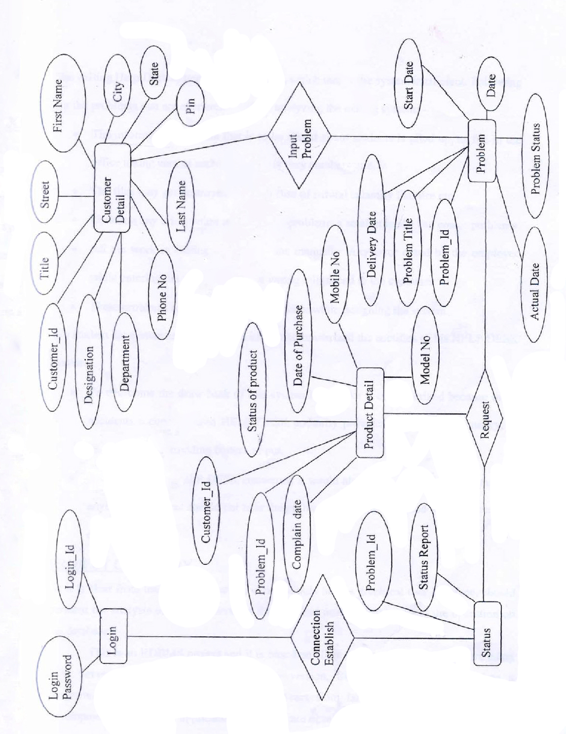

**­­**

**EXISTING SYSTEM**

The exiting help desk system faces problems, which makes the system inefficient. Following are the problems that are encountered while analyzing the existing system:-

* The information and data that is to be stored about students is piled up, as file in the office taking care of such document is very cumbersome.
* The files may get destroyed in the in case of natural calamity like fire etc.
* Updating any information make causes problems a small mistake can create problems.
* All the work in existing system is done manually any error caused by the employee while entering the data result into a wrong bill placed to the customer.
* These problems are taken into consideration while designing the system.

We student his system and suggest and idea to computerize the acetifies of his HELPDESK OF MOBILE PRODUCT.:-

To overcome the drawback of this system is to make it computerized because in all accidents a computerized help desk authority provides accuracy, consistency, in its flow and us providing better output.

* In computerized HELP DESK concerned it would always be in mind of the head that anyhow the student should not bear the problems and must get good service rater than others.

**PROJECT CATEGORY**

As it is clear from using an application, which should have a graphical user interface, should perform the analysis of user requirements that the user needs a database and the operation on the database.

This is an RDBMS project and it is based on client server environment. We are using SQL Server as RDBMS. With every new version, SQL server has evolved into a programming language. It has grown over years from language introduced for simple development of graphical application with software development component.

**SOFTWARE & HARDWARE REQUIREMENTS**

**Software**

Client Side :HTML, CSS & Java Scripting

Server Side : PHP

Back end : Mysql

Operating system : Windows XP. And Later

Web server : Apache Tomcat or GlassFish

**Hardware**

Intel Pentium 4 Processor

512MB RAM

20GB Hard disk

Hardware Management Software

Power Supply

Color Monitor

Key Board

Mouse

LAN card/Modem

Printer

**DATABASE TABLES**

**LOGIN**

|  |  |  |
| --- | --- | --- |
| **Field Name** | **Data Type** | **Size** |
| Login_Id | Varchar | 10 |
| Password | Varchar | 15 |

**PROBLEM**

|  |  |  |  |
| --- | --- | --- | --- |
| **SR.No** | **Field Name** | **Data type** | **Size** |
| 1 | Problem_Id | Varchar | 6 |
| 2 | Problem_Title | Varchar | 15 |
| 3 | Problem_status | Varchar | 20 |
| 4 | Problem_Type | Varchar | 10 |
| 5 | Date | Date |  |
| 6 | Start_date | Date |  |
| 7 | Actual_Date | Date |  |
| 8 | Delivery | Date |  |

**PRODUCT DETAILS**

|  |  |  |  |
| --- | --- | --- | --- |
| **S.R.No** | **Field Name** | **Data Type** | **Size** |
| 1 | Date_Of_Purchase | Integer |  |
| 2 | Status_Of_Product | Varchar | 10 |
| 3 | Problem_Id | Varchar | 15 |
| 4 | Customer_Id | Varchar | 15 |
| 5 | Complaint_Date | Integer |  |
| 6 | Model_No | Integer |  |
| 7 | Mobile_No | Integer |  |

**CUSTOMER DETAILS**

|  |  |  |  |
| --- | --- | --- | --- |
| **SR.No** | **Field Name** | **Data type** | **Size** |
| 1 | Customer_Id | Varchar | 6 |
| 2 | Title | Varchar | 15 |
| 3 | First_Name | Varchar | 15 |
| 4 | Last_Name | Varchar | 12 |
| 5 | Designation | Varchar | 15 |
| 6 | Department | Varchar | 15 |
| 7 | Street | Varchar | 15 |
| 8 | City | Varchar | 10 |
| 9 | State | Varchar | 10 |
| 10 | Pin | Integer |  |
| 11 | Phone_Number | Integer |  |

**STATUS**

|  |  |  |  |
| --- | --- | --- | --- |
| **SR.No** | **Field Name** | **Data type** | **Size** |
| 1 | Problem_Id | Varchar | 6 |
| 2 | Status_Report | Varchar | 25 |

**SECURITY MEASUREMENTS TAKEN**

Security and controls are required not only for preventing inadvertent mistakes made by user, but also to prevent misuse of the system and ensure data integrity.

In an automated system of Helpesk the following security measures have been considered:

1. Access control

Access Control can be defined as control established to ensure that only people with the proper authority have access to the data. Different types of access control, which are used in this software, are as Follow:

1. Transaction Access

All users of system need to have access to all transactions in a system. Users must have access only to transactions, which are required by them for their day-to-day operations. A manager in a office needs to submit his daily report only, Thus he should not have access to the Office records.

1. Data Access

Apart from having access to transaction, which are required for daily operations, users must only be allowed to see specific instances of transactions. In some applications it may be required that users must only see data relating to their needs. Thus the head of the department will have access to the department query transaction, but the user will not be shown all data, the user will be shown data belonging’s to the user’s department only.

In Help Desk Management, a user cannot see the details of the records entered.

C) Physical Access

The best form of access control is the physical access control. Only authorized personal should be allowed to do specific tasks like booting of the machine, mounting disks, distributing reports etc.

In this software the database is centralized means all the data Is stored at one place called as server whereas number of clients are attached to it. Without the server nothing can be done. So, for starting server an authorized person should be there.

1. Validations

Validations of data entered on various input screens are not a security for the system but a control to ensure that clean data goes into the system. If data is not validated on input, you will end up with a lot of inconsistent data.

In computer parlance, this is referred to as ‘Garbage In, Garbage Out’. If proper validation is not done, user tends to lose confidence in the system and it eventually boils down to a new project of clearing up the data. Typical validations done on input screen are as follows:

* Length of data.
* Type of data (numeric, integers, alphabetic, alphanumeric)
* Validation against masters
* Discreet values
* Cross validation of data across various fields

1. Data Integrity

We can have the best of validations in a system but invalid data can always get into the system due to some recent changes done on the software, which was not tested comprehensively, or due to corruption. Whatever the cause, it is a very good control practice to periodically check the integrity of the data o the system. Data Integrity could be verified by a number of techniques. Some of the used techniques are listed below:

* Tallying number of records across various tables in the database.
* Tallying critical fields across tables in the database.

Whatever be the techniques, periodic validation of the data will gives us early warning signals in case something in wrong with the database.

**FUTURE SCOPE OF THE PROJECT**

For future use, there are so many provisions specified with the help of

Which the system can also survive in the future with its excellent

capacity and robustness. With the help of these provisions, the system

may also be used for different helpdesk like power house ,reservation etc.

**BIBLIOGRAPHY**

WEBSITES

* [www.google.com](http://www.google.com)
* [www.wikipedia.org](http://www.wikipedia.org)
* [www.w3schools.com](http://www.w3schools.com)
* [www.youtube.com](http://www.youtube.com)

**BOOKS**

* “Beginning PHP and MySQL From Novice to Professional” by W Jason Gilmore
* “PHP: A Beginner’s Guide” by Vikram Vaswani
* “Learning PHP 5” by David Sklar
* “PHP Object – Oriented Solutions” by David Powers